Tom Watson statue removed from Georgia’s Capitol steps
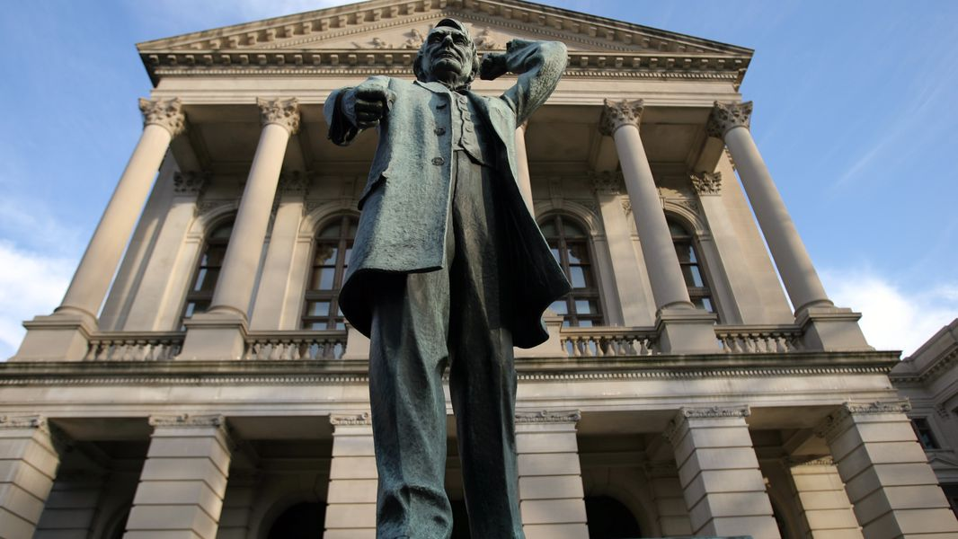
This statue of Thomas Watson sits at the entrance to the Capitol in this 2006 photo.
NEWS| Nov 30, 2013
By Kristina Torres
Crews removed Tom Watson’s statue Friday from the steps of the Capitol, with few prying eyes to see since offices were closed for a state holiday.
The work came a month after state officials acknowledged their plans to relocate the bronzed Watson, a one-time populist turned white supremacist who vilified blacks, Catholics and Jews.
Friday, crews wrapped Watson’s fist-pumping likeness in a bundle of blue moving blankets and duct tape. A crane then hoisted it and the statue’s heavy stone base away from the state Capitol’s west steps. It will be permanently relocated to a park across the street.

Gov. Nathan Deal approved the statue’s relocation but has stressed the decision was based on safety: The west steps are deteriorating, and the state plans to renovate both them and the entrance to the building.
Plans for the removal drew both cheers and jeers. Groups including Georgia’s Sons of Confederate Veterans urged Deal to bring the statue back to the Capitol once workers completed the renovation project. Others including the Anti-Defamation League applauded the move.
Watson, a former state lawmaker, congressman and U.S. senator, was viewed by many as a hero when his statue was dedicated in 1932. He came to prominence in the late 1800s, championing the needs of poor farmers and sharecroppers of all races. That support waned with time. Watson, who owned a weekly newspaper, endorsed taking the vote from African-Americans and launched anti-Jewish and anti-Catholic diatribes in his editorials.
State officials never explicitly said when workers would remove the statue, except that it would be mid-November. As it happened, offices were closed Friday as part of the state’s belated observance of Robert E. Lee’s Jan. 19 birthday.

